Module #2
What Do Plants Need To Grow

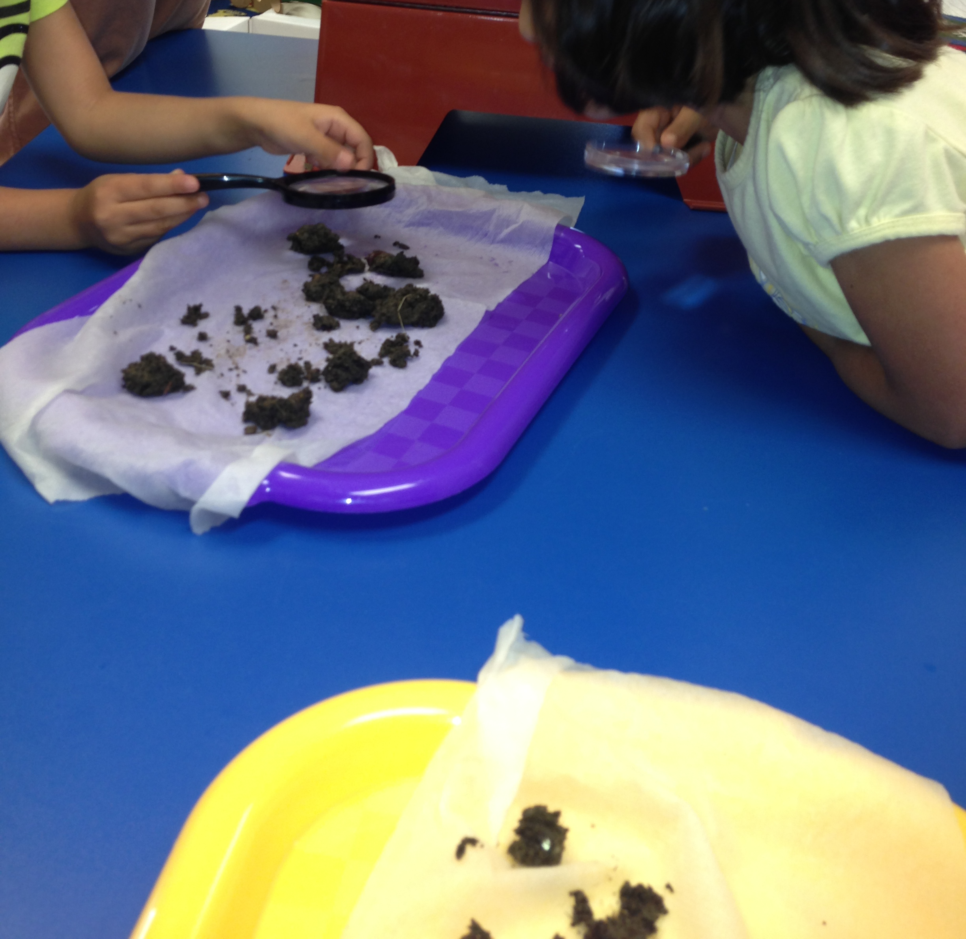

Driving Question(s)
What does a plant need to grow?
What is in the soil?
Which soil will be the best to grow plants?
Why are weeds bad for our garden?

Overview
Student will explore and determine what materials / resources are needed to begin a garden. They will determine what type of soil is best to grow vegetables in as well as how much soil is needed. The students will also determine the type of vegetable seed they will plant. Other things the students will need to consider, would be, what tools will be needed to maintain the garden as well as to use them. The students will need to decide how they wish to track and document the plant growth.

Major Products & Performances
Lesson 1-Preparing to Garden/Three Important Things That Plants Need to Grow
Lesson 2- Examining Different Soils
Lesson 3 – Worms
Lesson 4 - What Tools are Needed for Gardening? How are They Used?
Lesson 5 – What are weeds?

Teacher Background
Before starting to plant it is recommended that the ph balance of the soil be checked. The optimal range is for the ph balance should be 6 – 7. Soil needs some organic material, which can come from compost or well rotten manure. There are three nutrients that all plants need. They are nitrogen, which can be found in manure, phosphorus, found in bone meal, and potassium, found in wood ash. Too much sand my make the soil to dry and to much clay can make the soil to wet. Internet resources can also be a valuable tool. The children have successful in growing cucumbers and carrots in our classroom. They understand the need for the plants to have sunlight as well as the fact that they need water. The children also help to care for the worms that are housed in our worm bin making vermicomposting. The worms helps to provide air back into the soil. We have found out that feeding the worms apples will cause fruit flies to appear in your classroom. Vegetables such as carrots, corn and green beans are great to feed the worms. The worms really enjoy eating broccoli but it leaves a terrible smell in the room.

Growing Tips:
Choose the proper plants for your area. (This information can be found on the back of the seed packet)
Make sure that the plants have the proper light, food, water and temperature (can be found on the back of the seed packet)
Keep weeds out of the garden so not to compete with the plants for air, water, and nutrients.

Facts Related to Standards:
Introducing preschool children to gardening affords them natural learning opportunities to observe and understand the living world (Science -2.) Interactive discussions promote listening and speaking skills (Language Arts / Literacy-1.) Approaches task with flexibility and persistence to complete the project (Social and Emotional 4.3/ 4.4). Lessons can be adapted to target specific standards or used as listed for cross disciplinary purposes.

Title/Focus | Lesson 1-Preparing to Garden / Three Important Things That Plants Need to Grow
Teacher and Grade Level | Pre-K
Overview | Students will be discussing what a plant needs in order to grow and be strong.  They will get their information through informational text, read aloud, by asking questions, and making observations.
Standards | Science  1.1 Express wonder and ask questions about the world around them.  1.3 Investigates and problem solves  Language  1.1 Demonstrates an increasing ability to attend and to understand  Communication,  1.3 Understands and uses increasingly complex and varied  vocabulary/sentences in listening and speaking.
Materials/Advance Preparation Needed | Cups with healthy plants in them.  Map out where each cup will need to be placed. (sunny area, shady area, watered, dry area.) Books explaining how plants grow / what they need to grow.
Procedures/Steps | In the classroom show the children the plants and talk about what is needed to keep the plants alive and healthy. Explain that we are going to try a little experiment of our own. Have the children place the cups of vegetables  In the designated areas. Children’s observations will all be recorded
Assessment (What will be the evidence of student learning?) | Students need to be able to tell the three things that our plants need to grow.  Be able to explain why some of the plants did not live.

Title/Focus | Lesson 2-Examining Different Soils
Teacher and Grade Level | Pre-k
Overview | Students will look at soils collected from different locations and examine to see what it contains. Then students will predict which soil will be the best to grow the vegetables in. Students will then plant a few seeds in the different soils to see which produces the most growth.
Standards | Science  1.1 Express wonder and ask questions about the world around  them.  1.2 Observes and discusses similarities and differences among objects and materials, including cause and effect.  Math  3.4 Classify objects according to common characteristics, such as color, size, or shape.  Social  2.1 Develops positive relationships with children and adults.  2.6 Uses appropriate communication skills to initiate or join classroom activities.  Language  1.1 Demonstrates an increasing ability to attend to and understand  communication.
Materials/Advance Preparation Needed | Dirt detectives http://www.pbs.org/teachers/connect/resources/6948/previews/  Soil from different locations, cups, spoons, seeds, water, tray to examine soil, magnifying glasses, chart/paper to write their observations on.  Gather different soil samples (potting soil, rocky soil, soil from worm bin)  Children can bring in soil from other locations if they would like.
Procedures/Steps | This lesson will start in the classroom.  Students will watch a presentation on the internet called “Dirt in Dirt,” starring Sid The Science Kid.  Students will look at different trays of soil.  They can take turns looking at the soil using magnifying glasses to compare, do they look or feel different?  Chart their comments about the soil.  Children will then put soil from tray into a cup.  Each tray of soil will be put in an individual cup and then the children will plant three seeds into each cup.  Cups will be placed in a sunny and safe place outside.  The children will make their predictions on which soil they feel is the best and why.  Then children will check the plants regularly and discuss which soils seem to be the best for growing vegetables.  A photo journal will be updated regularly to help with the observation of the growth of the plants and a chart will be made to show which soils seem to produce the healthiest plants.
Assessment (What will be the evidence of student learning?) | Students will be able to make comments about the soil, such as how it is different or the same. Students should be asking questions. Photos will be used to help students explain what the findings show.

Title/Focus | Lesson 3-Worms
Teacher and Grade Level | Pre-K
Overview | The purpose of this lesson is to introduce the worms and the worm bin. The children will learn how to care for the worms as well as worm exploration.
Standards | Science  1.1 Expresses wonder and asks questions about the world around them.  1.2 Observes and discusses similarities and differences among objects and materials, including cause and effect  1.3 Investigates and problem solves through active exploration of the environment.  1.4 Progresses in ability to describe and discuss predictions, explanations, and generalizations.  1.5 Uses senses and a variety of tools to gather information, investigate materials, and observe processes and relationships  1.6 Collects, describes, and records information through a variety of means to lead to new understanding of the world around them.  2.1 Observes and describes the immediate and familiar world, such as the natural world, materials, living things, and natural processes.  2.2 Shows increased awareness and beginning understanding of changes in materials and cause-effect relationships, such as recognize that materials can exist in several physical states.  2.3 Demonstrates expanding knowledge of and respect for the environment.  Math  1.3 Uses one-to-one correspondence in counting objects and matching groups of objects.  3.1 Understand that objects have measurable attributes, such as length or weight. A single object might have several measurable attributes of interest.  3.2 Estimates the size of objects in comparison to a common unit of measurement, such as more/less, short/tall, long/short, big/little, and light/heavy.  Social And Emotional  1.3 Develops growing capacity for independence in a range of activities, routines, and tasks.  2.3 Demonstrates increasing capacity to follow rules and routines and use materials purposefully, safely, and respectfully.  2.6 Uses appropriate communication skills to initiate or join classroom activities.  2.8 Begins to share materials and experiences and take turns.  2.10 Accepts guidance and directions from a variety of familiar adults.  4.3 Approaches tasks and activities with flexibility, imagination, and inventiveness.  4.4 Persists in and completes tasks, activities, projects, and experiences.  4.6 Maintains increasing concentration over a reasonable amount of time despite distractions and interruptions.  Language Arts/Literacy  4.1 Progresses from using scribble shapes or pictures to represent ideas, to using letter-like symbols or invented spelling, to copying or writing familiar words such as his/her own name.
Materials/Advance Preparation Needed | Review Project WILD "worm" activities/lesson plan-make preparations for recommended activities as stated-wet paper towels Growing Up Wild.Council for Environmental Education  Pair up children-worm buddies  Previous week-set out worm books in library, note/attend to "worm" sightings outside
Procedures/Steps | Following student's lead, provide interactive, purposeful, engagement experience including but not limited to the following activities:  - Lead discussion about what we know and what we may want to know about worms-document on chart paper for children to see.  - Discuss how worms help our soil.  - Provide hands on experience with the worms-provide pairs of children a wet towel, "sampling" of dirt w/ worms from the worm bin, circulate among the pairs and ask questions about what they see, feel, smell. Model/encourage use of descriptive vocabulary.  Encourage children to draw picture/Journal entry of worm experience
Assessment (What will be the evidence of student learning?) | Take anecdotal notes during discussion, audio recording  Take Pictures/Video  Picture with documented dictation

Title/Focus | Lesson 4-What Tools are Needed for Gardening? How are They Used?
Teacher and Grade Level | Pre-K
Overview | The purpose of this lesson is to explain what a tool is. Then show the students different tools that are needed to work in the garden, as well as how to use them.
Standards | Social Relationships  2.3 Demonstrates increasing capacity to follow rules and routines and use materials purposefully, safely, and respectfully.  2.6 Uses appropriate communication skills to initiate or join classroom activities.  2.8 Begins to share materials and experiences and take turns.  2.10 Accepts guidance and directions form a variety of familiar adults.  2.11 Follow basic routines and rules for play and group participation.  Language  1.2 Communicates needs and wants through a variety of verbal and symbolic forms.  1.6 Listens to others and take turns speaking  1.7 Asks questions to get information, seeks help, or clarifies something that is not understood.  Literacy  2.3 Demonstrates increasing awareness of concepts of print, such as reading moves from top to bottom, left to right, speech can be written down, and print conveys a message.  2.12 Recognizes a word as a unit of print.
Materials/Advance Preparation Needed | Soil, spades, hand rakes, trowel, watering can, raised bed garden  Gather the tools that will be introduced, so the children can see them and touch them. Have the printed word to go along with the tool and a bag Have a raised bed for children to practice the correct way to use the tool.
Procedures/Steps | Start this lesson in the classroom. Show the students the different tools.  Tape the name of the tool to it or place the name of the tool on the floor in front of it.  Have the students draw a paper from the wicker basket. (paper has the name of a tool printed on it.)  The student will match the printed word to the actual tool.  Have children repeat the name.  When all papers have been drawn and all tools labeled take the tools outside to our raised bed and let the children practice using the tools.
Assessment (What will be the evidence of student learning?) | Students should be able to recognize or name the tool and explain how to use the tool in the garden.

Title/Focus | Lesson 5-What are Weeds?
Teacher and Grade Level | Pre-K
Overview | The purpose of this lesson is to help the students understand the differences between a weed and a garden plant. The students will gain an understanding that weeds take needed food and water away from the garden plants. Students will recognize weeds in the garden and remove them.
Standards | Science  1.2 Observes and discusses similarities and differences among objects and materials, including cause and effect.  1.3 Investigates and problem solves  Math  3.4 Classify objects according to common characteristics, such as color, size, or shape.  Social  2.3 Demonstrates increasing capacity to follow rules and routines and use materials purposefully, safely, and respectfully.  2.6 Uses appropriate communication skills to initiate or join classroom activities.  2.8 Begins to share materials and experiences and take turns.  2.10 Accepts guidance and directions from a variety of familiar adults.  4.1 Participates in a variety of classroom activities and tasks.  4.2 Developes increased ability to make independent choices.  Language/Literacy  1.1 Demonstrates an increasing ability to attend and to understand communication.  1.7 Asks questions to get information, seeks help, or clarifies something that is not understood.  2.12 Recognizes a word as a unit of print.
Materials/Advance Preparation Needed | Pictures of various common weeds, and cards with the names of the weed printed on them. Books with informational text about different plants and weeds.  Teacher needs to walk and scope out the areas that the class could walk so that they can look for and identify weeds.
Procedures/Steps | While in class meeting, talk about weeds, what they are, what they look like and why they need to be removed from the garden. Show/display pictures of various common weeds from the area.  Next go outside for a walk. Children should be holding a picture of a weed that he/she is responsible to find while on their walk.  (The teacher should have scoped out the area to make sure the pictures the children are given are available and not to difficult to find.)  Following the walk have the children meet for a short time to talk about their experience,  Discuss and show pictures of the following types of weeds.  Posion - Leaves of 3 Rhyme –Leaves of 3, let them be!  Dandelions  Creeping Charlie  Common Plantain  Pictures and informations found on the internet-  www.landscaping.about.com  Common Lawn Weeds
Assessment (What will be the evidence of student learning?) | Children should be able to recognize and pull out any weeds in their garden. Talk about and show pictures of lawn weeds such as a Dandelion, Creeping Charlie, Common Plantain.

