Title | Parent Night Presentation
Overview | Students will help prepare a presentation for parents to show them what they have learned. They will practice the presentation. If you have a school garden, students will try to get their parents to help care for the plants over the summer weeks.
Standards | ELA.2.R.C2.4: Determine the meaning of words and phrases in informational text relevant to a grade 2 topic or subject area.  ELA.2.R.C3.3: Explain how specific images (e.g., a diagram showing how a machine works) contribute to and clarify an informational text.  ELA.2.SL.C14.3: produce complete sentences when appropriate to task and situations in order to provide requested details or clarification.  ELA.2.SL.C14.1: recount an experience with appropriate facts and relevant, descriptive details, speaking audibly in coherent sentences.  ELA.2.W.C10.3: With guidance and support from adults, use a variety of digital tools to produce and publish writing, including in collaboration with peers.
Materials/Advance Preparation Needed | Day 1  - Send home a note asking parents who will be able to attend the parent night so you will know who will be presenting.  - Gigapan picture (if Gigapan site is unavailable use a zoomed in picture and normal picture of a strawberry plant) Teacher should already have this on the smart board at the start of the lesson. Use website http://gigapan.com/gigapans/154691, the image was posted by Melissa Forinash.  - Chart paper/markers (have OWL prepared on the chart before the lesson) *See Teacher Background for an example of OWL chart  - Index cards  Day 2  - PowerPoint prepared by teacher  - Caretaker’s guide prepared by teacher  - Sign-up sheet for summer weeks prepared by teacher  If you collaborate with another teacher you can break this lesson up and have one teacher teach day 1 and another teacher complete day 2 with two separate groups of students. Those students will be the ones presenting that particular part at the parent night.
Procedures/Steps:  (Emphasis on students making inquiry, e.g., posing questions/problems and working towards answers and solutions) | Day 1:  Introduction  - Whole Class: Tell students we will be having a parent night to teach our parents all about our strawberry plants and what we have learned. Make sure they understand that you will be modeling what they are going to do for their parents. Model using the vocabulary and terms taught throughout each lesson so the students will also use this language.  Lesson: Part 1 – Teachers model OWL chart  - Teacher will do an OWL (observe, wonder, learn) chart with students.  - Have students observe the picture on the screen. Remind the students that they are to only tell you what they see. As students tell you what they observe record their answers on the O of the OWL chart. (students will most likely know the picture because they have learned what strawberry plants look like)  - Now have students tell you what they wonder about the picture. Record their wonders under the W on the OWL chart.  - Reveal the full picture.  - Discuss and record what they have learned from their wonderings and record under the L on the OWL chart.  Lesson: Part 2 – Students practice and then present OWL chart to parents  - Have students come forward that will be doing this part of the presentation. You will need speakers and writers. The speakers will be asking the questions to the parents and the writers will be recording on the OWL chart. The students who will not be participating will be the audience for this group to practice.  - Prepare students to ask questions as the teacher would. If the audience says I see leaves. Have a student ask the question “What do you notice about the leaves?” (in hopes they will give you details, jagged, green, etc) See if the students can come up with statements or questions they want their audience to ask. (Another Example: I see a white flower. “What else do you notice about the flower?) Write these important questions on index cards. The teacher will help cue them on the night of the presentation.  - Have the writers record the answers on the OWL chart as the audience provides answers.  - Do this with wonders also.  - Have a student come forward and expose full picture and read the wonders to see what they have learned.  Day 2  Introduction:  - Whole Class: Remind students we will be having a parent night to teach our parents all about our strawberry plants and what we have learned. Make sure they understand that you will be modeling what they are going to do for their parents.  Lesson: Part 1  - Teacher models: Show students the power point and discuss each slide with them as you would want them to do it; be sure to use new vocabulary and terms used throughout the year.  Lesson: Part 2  - Have students who will be presenting this part of the presentation come up and give them each a slide to discuss.  - Students should practice talking about the slide to the student audience.  Closure:  - Bring both groups together to practice the entire presentation. You may want to do this with another class or use the students not attending the parent night as the audience again.
Assessment (What will be the evidence of student learning?) | Students tell what they observe and wonder. They decide what is important for the audience to observe and wonder by coming up with their own questions to ask. They speak about their own findings throughout this project.

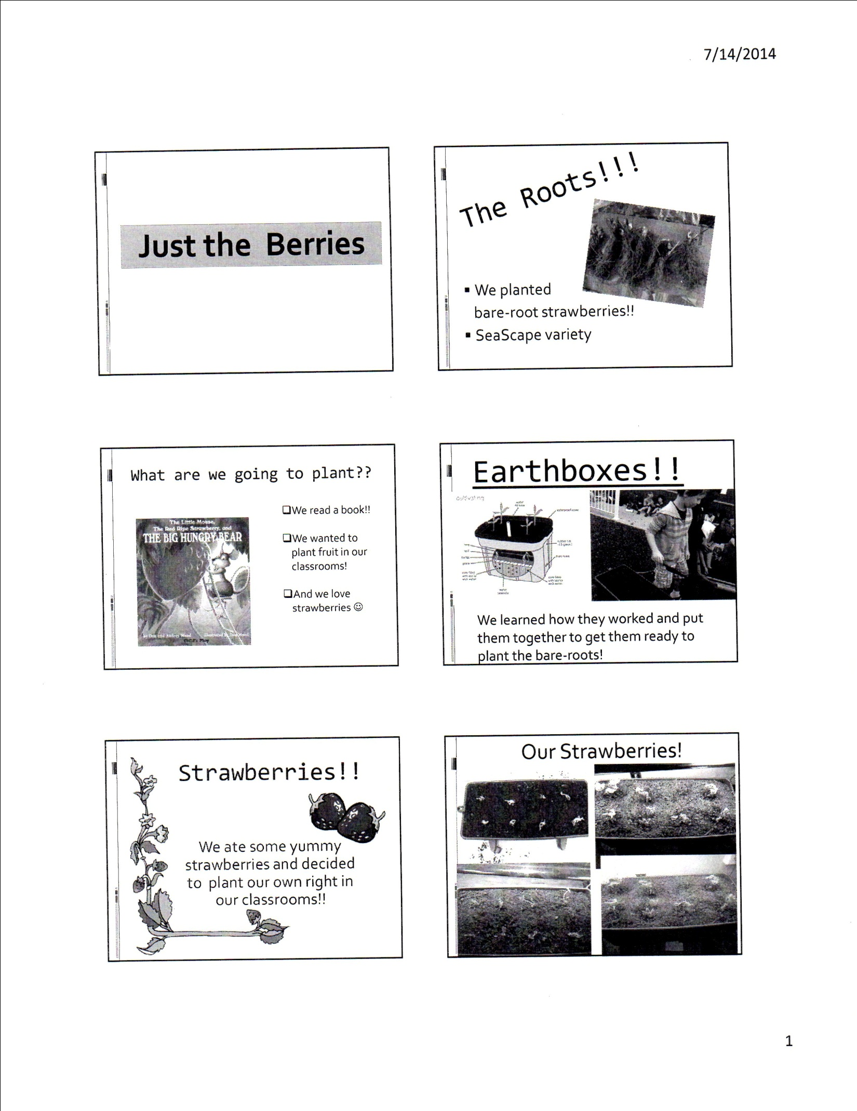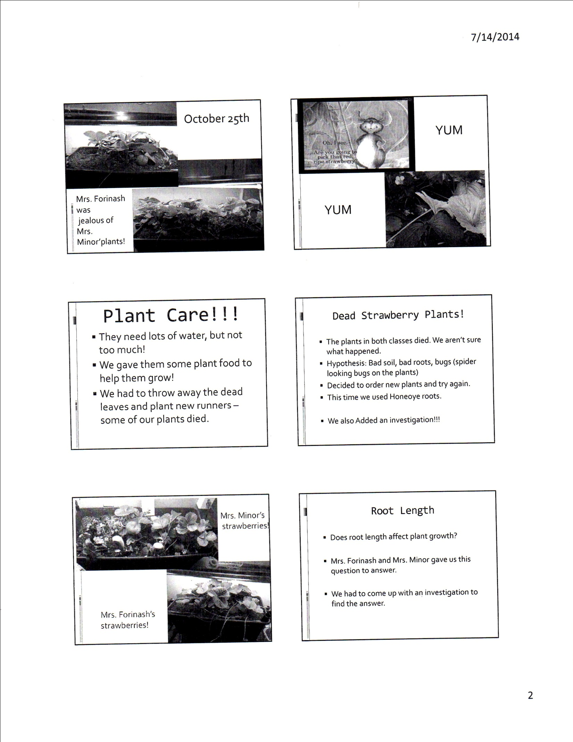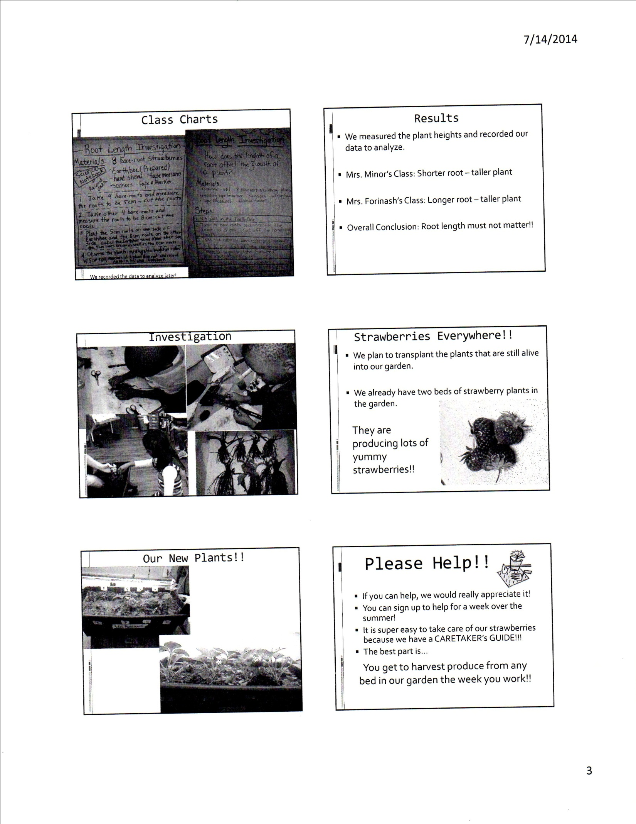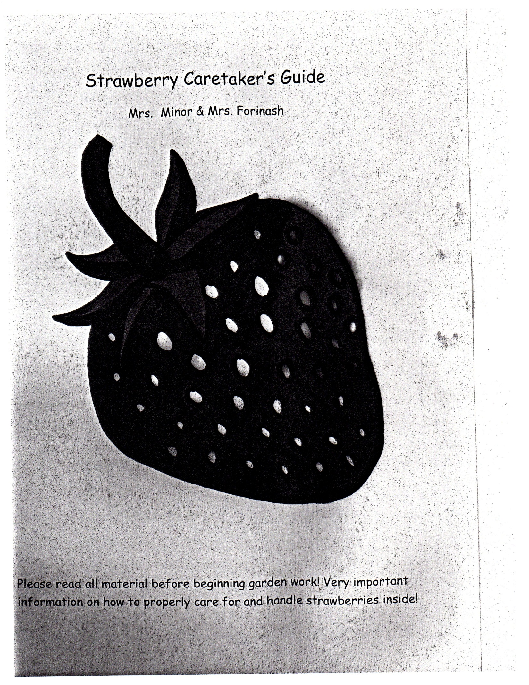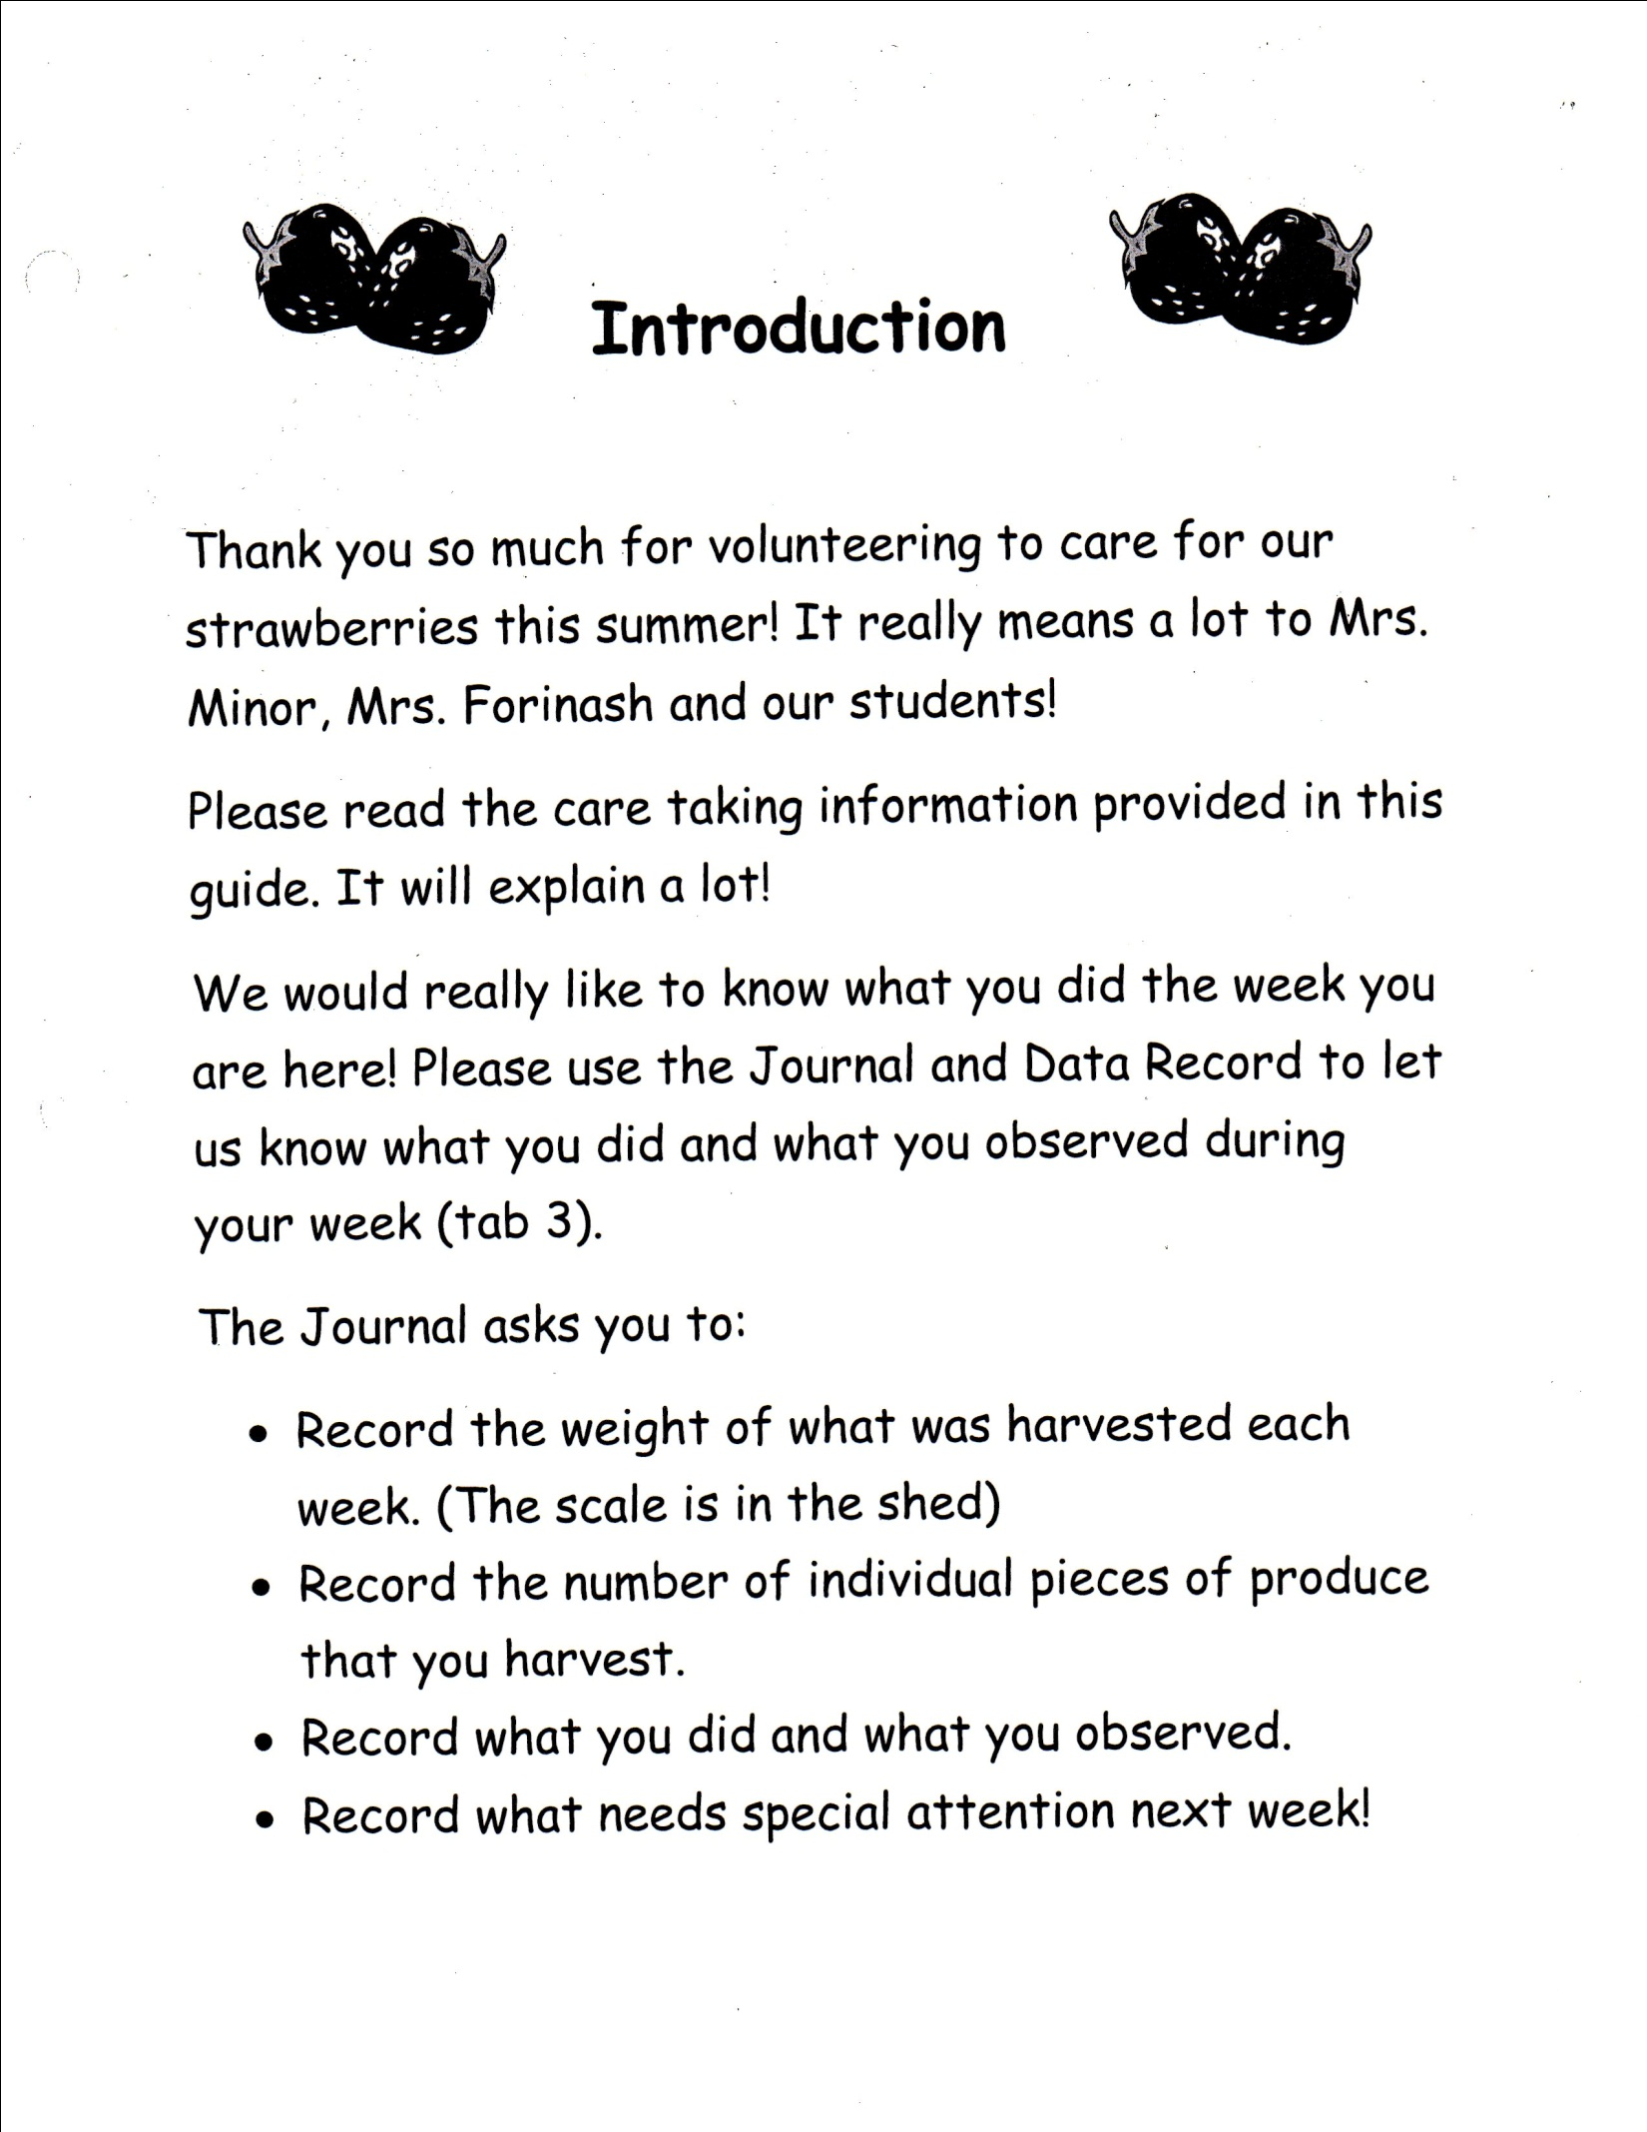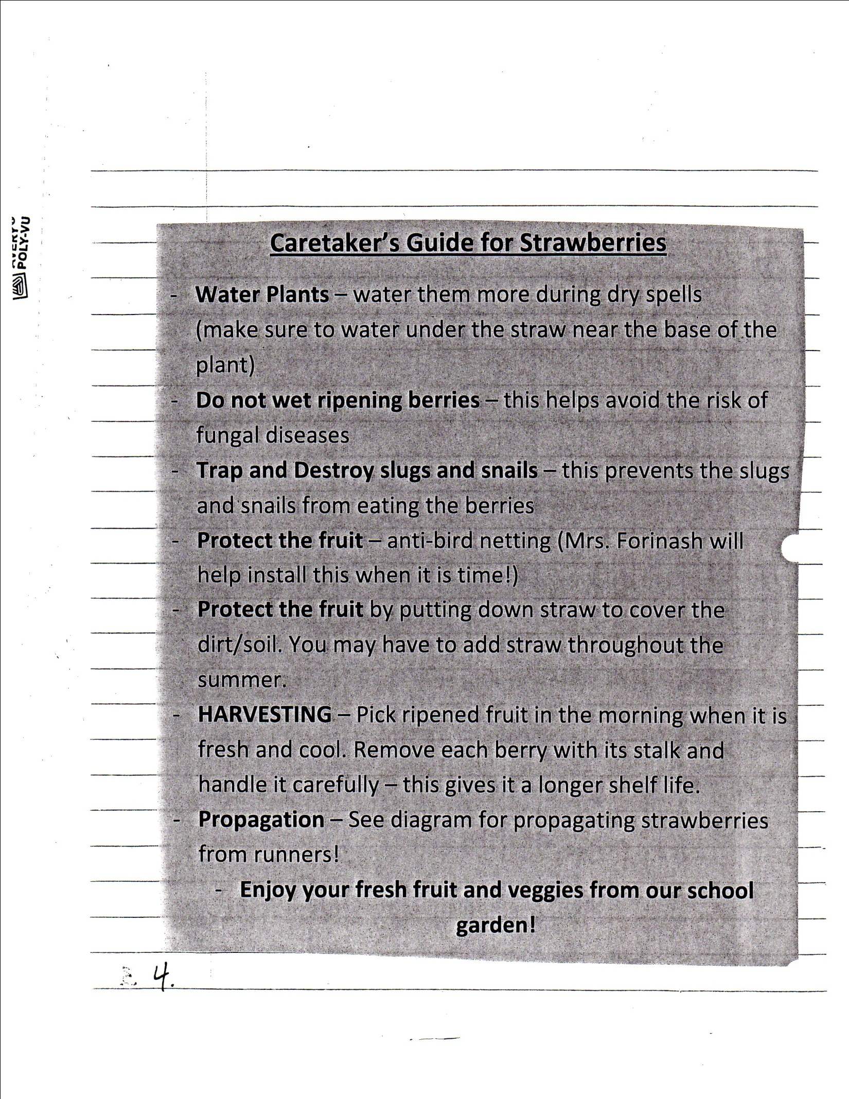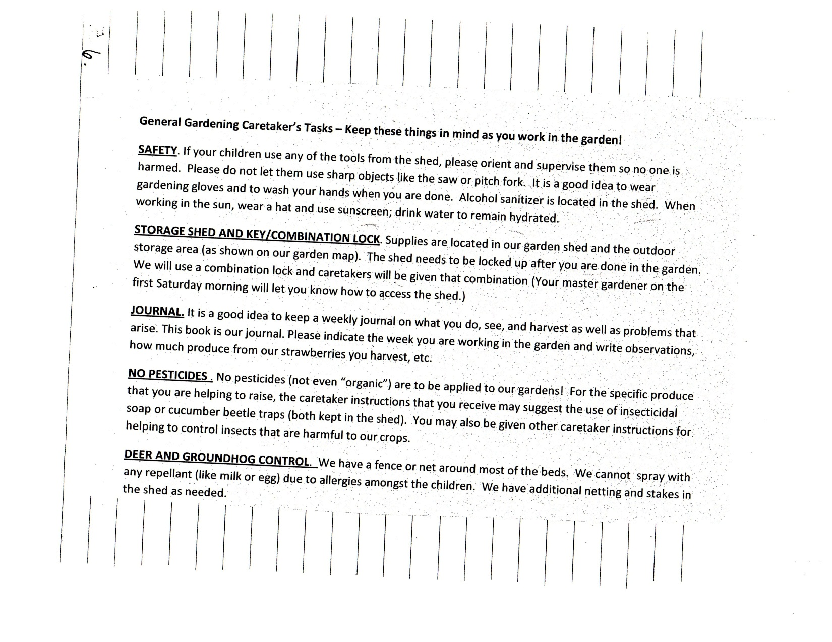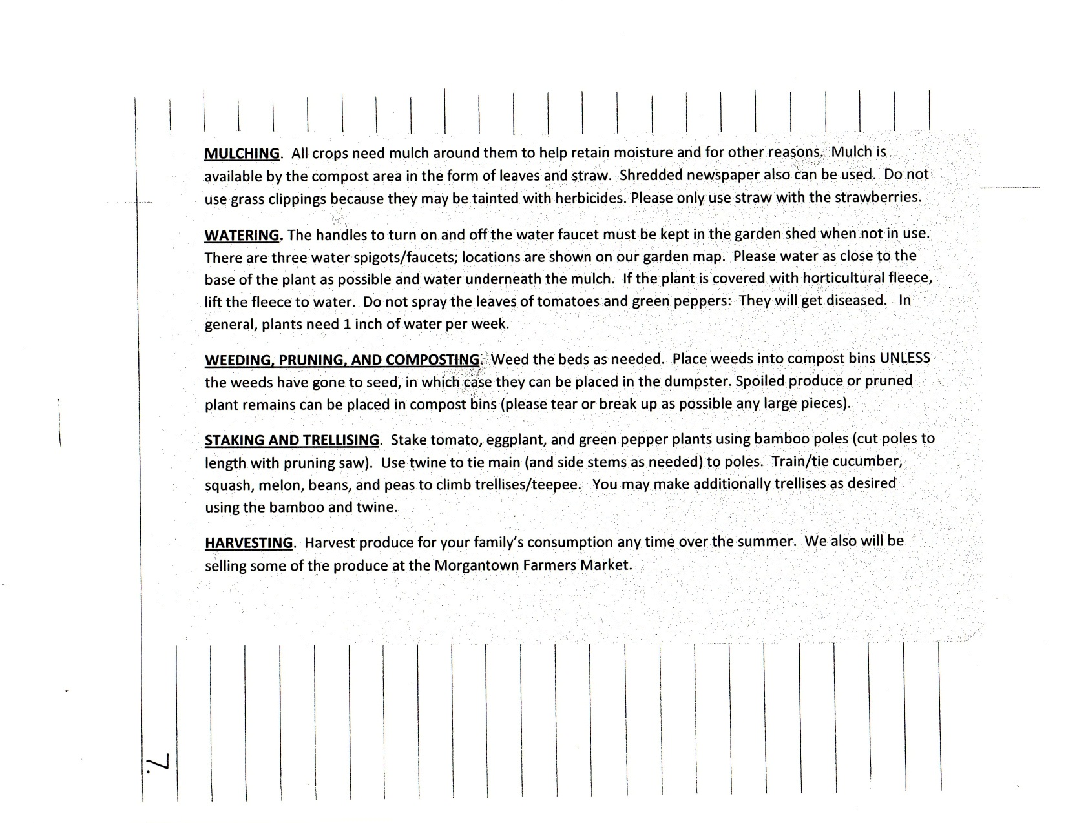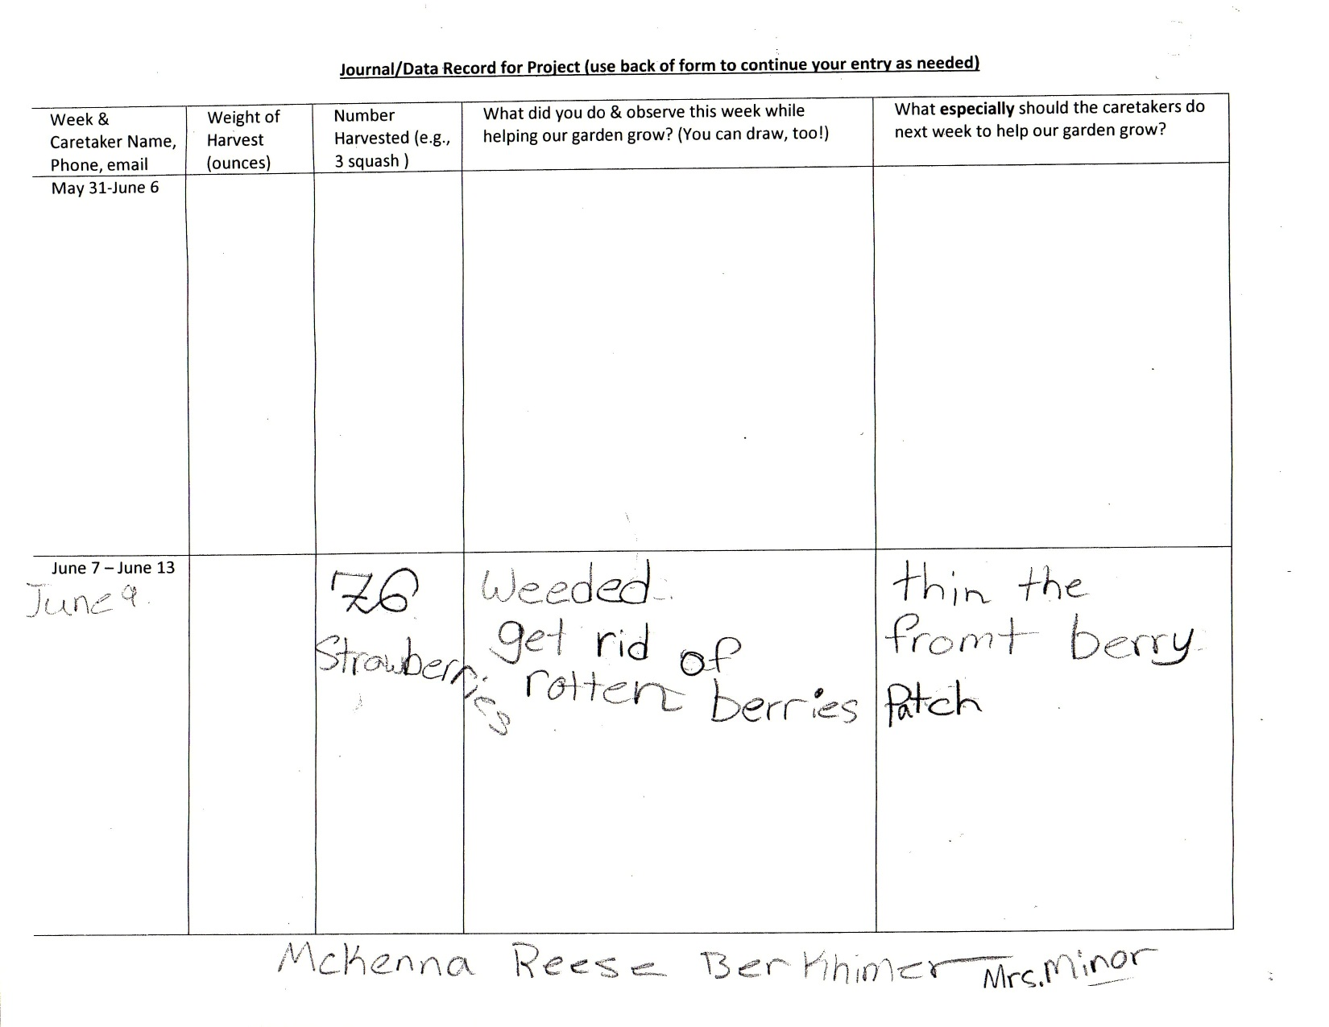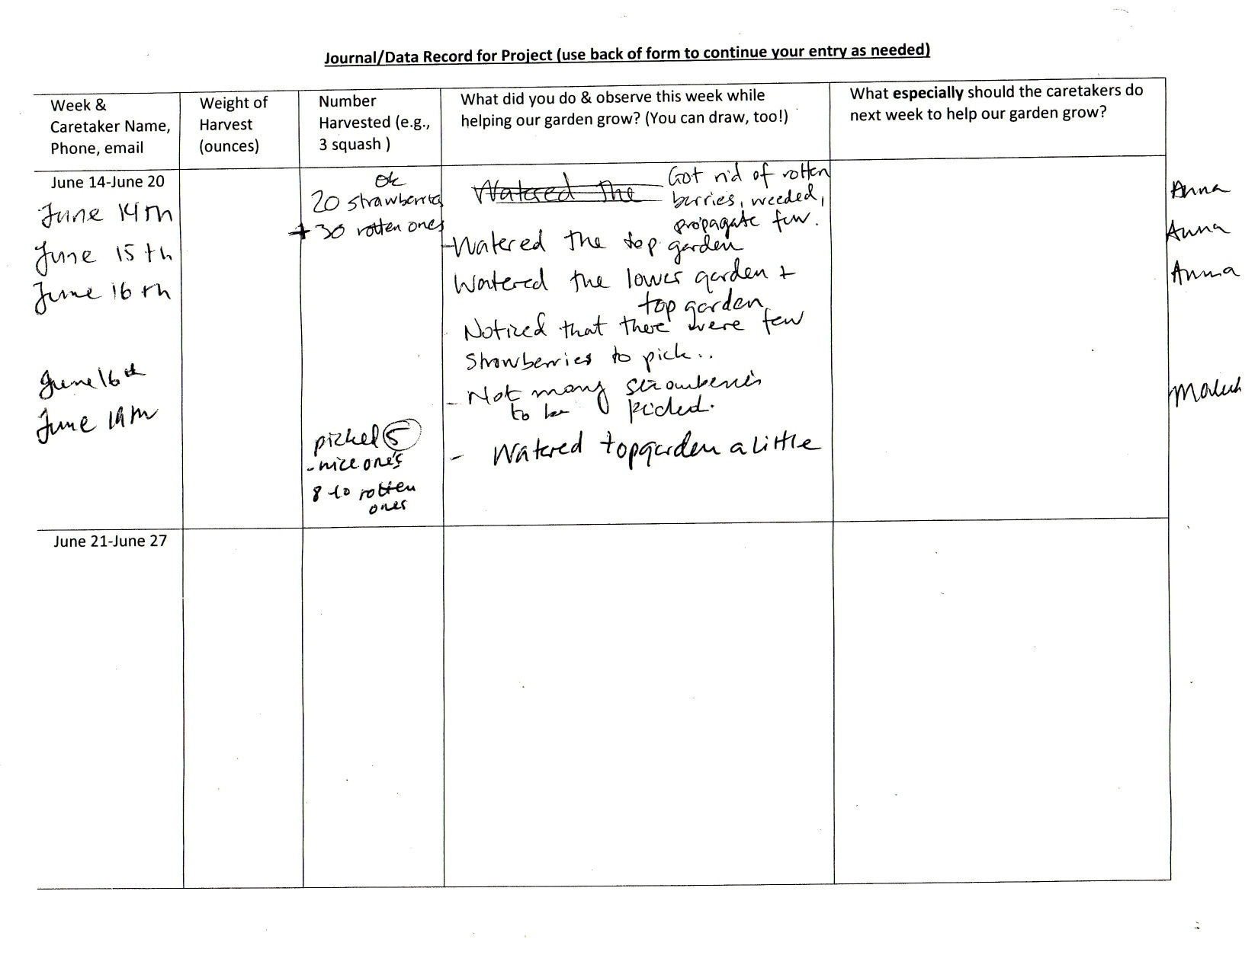
The PowerPoint we made with our students. Our students used this presentation on Parent Night.
The next 6 pages show our caretaker’s guide. The teachers and students made it together. This page is the cover.

