Title | Lettuce Learn
Overview | Students will plant a variety of lettuce seeds in different types of soils (including the worm soil) to compare which soil is the most successful
Standards | 1 ESS1-2 Make observations at different times of year to relate the amount of daylight to the time of year.
Materials/Advance Preparation Needed | -variety of lettuce seeds- green or red leaf lettuce  -at least 2 types of soil- you could use coconut soil, potting soil, wondersoil, or whatever is available  -worm bin soil- if class did Module 1  -trays for planting  -heating mats  -poster for Class Watering Chart  -grow lights  -garden journals
as needed so that each soil is about as a damp Procedures/Steps:  (Emphasis on students making inquiry, e.g., posing questions/problems and working towards answers and solutions) | - Help the students harvest the soil from the worm bin.  - Fill one tray with worm bin soil, one tray with worm bin soil and coconut (or other) soil mixed, and the last tray will be straight coconut soil. Add water to each soil so each soil is about as damp as a “wrung out” sponge. (squeeze a handful of soil and it should clump and a small amount of water should drip through your fist.)  - Divide students up into 3 groups and give each group a tray.  - Discuss with the students the proper techniques of planting. (Making small a hole before dropping seed in, don’t over seed, etc.) Discuss what season would be the best to plant lettuce. Explain why.  - Pass out popsicle sticks so students can label their tray according to the seed and soil they used. ( I did three different types in each tray but you can try as many or as few as you would like.)  - Once the trays are labeled and ready I pass out one type of seed at a time and help students to place them in the correct area of their tray.  - After all the seeds have been planted we place the trays on a heating mat and slightly cover them. (Once the seeds have germinated remove the hat mat or your seedlings will get spindly.)  - As a class we design a Class Watering Chart on a poster for everyone to see.  - Every few days instruct the students to observe and record the progress of the growth of the seeds in their garden journals.  Extension:  Students can predict in their garden journals which soil will grow the best lettuce and explain why.
Assessment (What will be the evidence of student learning?) | Students participation in planting seeds. Also check students garden journal for their observations.

Title | Research lettuce
Overview | Students sample a piece of lettuce. After observing and sampling the lettuce the class will complete a See/Think/Wonder chart about lettuce in their garden journals. Finally students will watch a clip on United Streaming about lettuce. If they still have wonderings they will get on the laptops and research their remaining lettuce questions.
Standards | 1 ESS1-2 Make observations at different times of year to relate the amount of daylight to the time of year.  1 LS3-1 Make observations to construct an evidence-based account that young plants and animals are alike, but not exactly like, their parents.  ELA.1.W.C11.1 participate in shared research and writing projects (e.g., explore a number of “how-to” books on a given topic and use them to write a sequence of instructions).  ELA.1.W.C11.2 with guidance and support from adults, recall information from experiences or gather information from provided sources to answer a question  ELA.1.SL.C13.2 ask and answer questions about key details in a text read aloud or information presented orally or through other media
Materials/Advance Preparation Needed | -laptops  -garden journals  -lettuce for sampling  -clip from United Streaming called “Farming and Agriculture: Plant Parts We Eat: Leaves and Flowers” ( I only show the 1:20 minutes about lettuce)  http://app.discoveryeducation.com/search?Ntt=lettuce
Procedures/Steps:  (Emphasis on students making inquiry, e.g., posing questions/problems and working towards answers and solutions) | - Give each student a piece of lettuce.  - As students look at the lettuce discuss the different parts of the plant. Ask students where the roots would be, stem, leaves, etc. Then allow students to try the lettuce.  - Instruct students to fill out a See/Think/Wonder chart in their garden journal about lettuce.  - Show the class the clip about lettuce from United Streaming. Ask students to listen for facts about lettuce they may not have known. After the clip make a chart of all the lettuce facts the class knows.  - If students still have questions about lettuce they can work with a buddy to research lettuce facts on the laptops.  - Students can share the new facts they discovered and add them to our chart.
Assessment (What will be the evidence of student learning?) | Check student’s chart and research facts for correct observations.

Title | Recruiting Help
Overview | Students will realize they are going to need to plant more lettuce if they want to grow enough to serve in the school cafeteria. They will write persuasive letters to a Kindergarten class to ask for help.
Standards | ELA.1.W.C9.1 write opinion pieces in which they introduce the topic or name the book they are writing about, state an opinion, supply a reason for the opinions and provide some sense of closure  ELA.1.SL.C14.3 produce complete sentences when appropriate to task situation
Materials/Advance Preparation Needed | -stationary
Procedures/Steps:  (Emphasis on students making inquiry, e.g., posing questions/problems and working towards answers and solutions) | - After observing and discussing the progress of the lettuce. Ask the students if they think they will have enough to serve in the cafeteria.  - Inform students that another teacher has offered to help but we must convince her students that we need their help. Make a list of reasons on the board to help convince the Kindergarten students to work with us in growing lettuce to serve in the cafeteria.  - Assign students a buddy to write a persuasive letter asking them to help grow lettuce.  - Deliver the letters to their partners.  Extension:  Students can add lettuce facts into the letters to help the Kindergarteners become excited about growing lettuce.
Assessment (What will be the evidence of student learning?) | Check over students’ letters for opinions about lettuce and complete sentences.

Title | Buddy Work
Overview | Students will meet with their Kindergarten buddies to share lettuce facts and begin planting more lettuce seeds. By this point students should know which soil works the best and inform their buddies about their experiment.
Standards | ELA.1.SL.C13.1 participate in collaborative conversations with diverse partners about grade 1 topics and texts with peers and adults in small and larger groups  ELA 1.R.C1.4 ask and answer questions about key details in an informational text
Materials/Advance Preparation Needed | -soil  -lettuce seeds  -trays  -grow lights  - Schuh, M. (2011) “Lettuce Grows on the Ground” Pebble Books
Procedures/Steps:  (Emphasis on students making inquiry, e.g., posing questions/problems and working towards answers and solutions) | - Invite the students’ buddies to come to their classroom to observe their lettuce success (or not) so far. Have students share lettuce facts with one another.  - As a group read and discuss the book “Lettuce Grows on the Ground.” Ask students to recall key details from the text.  - Divide buddies into 4 groups. I would try to have a parent volunteer or student teacher available to help with the planting. Allow the buddies to plant lettuce seeds into the trays.  - Each classroom can take care of 2 trays until they are ready to transplant.
Assessment (What will be the evidence of student learning?) | Student participation in conversations about lettuce and if they are able to ask and answer questions about lettuce.

Title | Comparing the Lettuce
Overview | Students will write letters back and forth between buddies to compare the lettuce plants.
Standards | ELA.1.W.C11.1 participate in shared research and writing projects (e.g., explore a number of “how-to” books on a given topic and use them to write a sequence of instructions).  ELA.1.SL.C13.1 participate in collaborative conversations with diverse partners about grade 1 topics and texts with peers and adults in small and larger groups  ELA.1.W.C9.3 write narratives in which they recount two or more appropriately sequenced events, include some details regarding what happened, use transitional words to signal even order and provide some sense of closure.
Materials/Advance Preparation Needed | -stationary
Procedures/Steps:  (Emphasis on students making inquiry, e.g., posing questions/problems and working towards answers and solutions) | - Students will continue to observe and water their lettuce plants.  - After a week or two they can write a letter to their buddy asking about their lettuce plant. They can give details about their plant as well. Buddies can write back and forth a few times before it is time to transplant the lettuce.  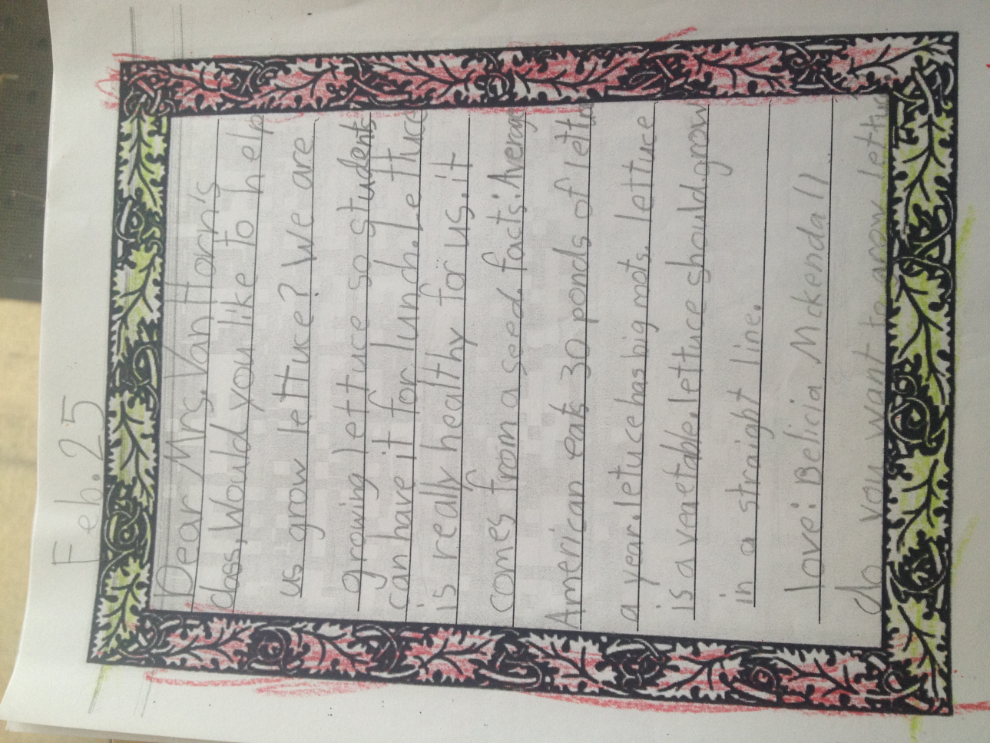  Extension:  Buddies could meet to read their letters to each other.
Assessment (What will be the evidence of student learning?) | Check students’ letters for 2 facts about their lettuce.

Title | Transplanting the Lettuce
Overview | Once the lettuce is ready to transplant students will become familiar with coordinate graphing and then transplant their lettuce outside.
Standards | ELA.1.SL.C13.1 participate in collaborative conversations with diverse partners about grade 1 topics and texts with peers and adults in small and larger groups  M.1.MD.4 organize, represent, interpret data with up to three categories, ask and answer questions about the total number of data points, how many in each category and how many more or less are in one category than in another.
Materials/Advance Preparation Needed | - Poster of coordinates for students to label their assigned section  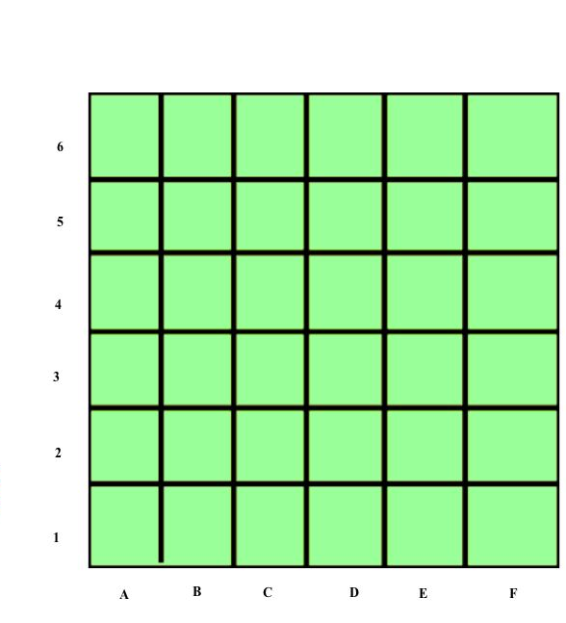  -Coordinate game board- large blank graph with numbers on one side and letters on the other.  -2 dice- one with letters to match the graph and one with numbers  -Plants ready to transplant  -Divide the garden bed up into 24 equal shares using string and label with index cards
Procedures/Steps:  (Emphasis on students making inquiry, e.g., posing questions/problems and working towards answers and solutions) | - Introduce the class to the coordinate game by spreading out the poster of a blank coordinate graph. Divide the students up into 2 teams red or blue dicuts. Teams will take turns rolling the dice and placing one of their game pieces on graph. The first team to get three in a row win.  - Next randomly place game pieces on the board. Students will take turns rolling the dice. If they roll a coordinate that has a piece on they get to keep the piece. When the board is cleared the game is over.  - After students become comfortable using a coordinate graph make a chart of the lettuce bed and divide it equally into 24 sections (or more depending on number of students). Students will sign up for a specific coordinate in the garden bed to transplant their lettuce. It will be their responsibility to water and care for the lettuce in their block.  - Take the class out to the garden bed that has previously been divided into 24 equal sections. Help students find their coordinate and transplant their lettuce in the correct space.  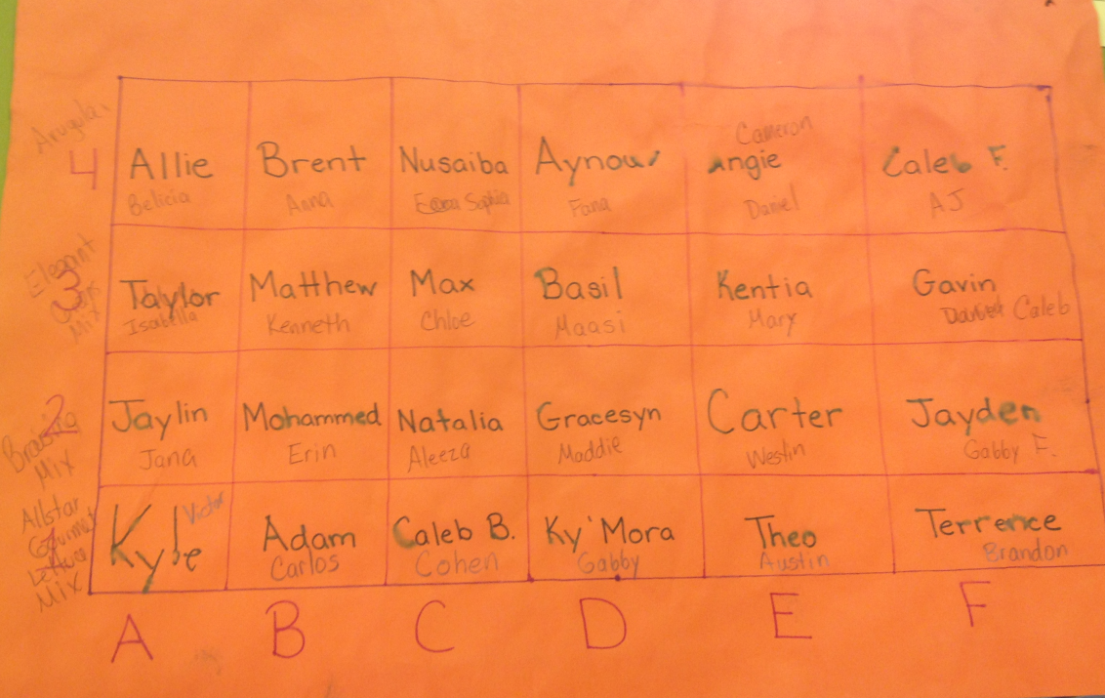  Extension:  This activity can be done with your buddy class and each buddy can be assigned a coordinate.
Assessment (What will be the evidence of student learning?) | Observe students’ understanding of coordinate graphing during the game. Check for comprehension when they label their space on the chart and then find the correct spot outside.
Title | Lettuce Stations
Overview | Students will rotate through 5 stations as they discover more about lettuce.
Standards | ELA.1.W.C9.2 write informative/explanatory texts in which they name a topic, supply some facts about the topic and provide some sense of closure  M.1.MD.4 organize, represent, interpret data with up to three categories, ask and answer questions about the total number of data points, how many in each category and how many more or less are in one category than in another.  M.1.MD.1 order three objects by length and compare the lengths of two objects indirectly by using a third object.  M.1.MD.2 express the length of an object as a whole number of length units, by laying multiple copies of a shorter object (the length unit) end to end and understand that the length measurement of an object is the number of same-size length units that span it with not gaps or overlaps.
Materials/Advance Preparation Needed | -Digital Scale  -crayons  -4 square writing template  -garden journals  -rulers, blocks, paper clips
Procedures/Steps:  (Emphasis on students making inquiry, e.g., posing questions/problems and working towards answers and solutions) | - Set up 4 stations around the room.  Station 1: Comparing Station: Students will compare red to green lettuce( or any 2 types of lettuce). Students can record in their garden journals similarities and differences.  Station 2: Weight Station: Students will weigh four different pieces of lettuce and order them from smallest to largest. They will write the weights in their garden journals.  Station 3: Sample Station: Students can try the different types of lettuce that they planted. They will then mark off on the graph which kind they liked the best. In their garden journal they will write why they chose the leaf they did.  Station 4: Leaf Rubbing: Students will pick different pieces of lettuce to rub into their garden journal using a crayon. They can label the parts of the leaf if there is time.  Station 5: Measuring Station: Students will measure a variety of lettuce leaves using paper clips, rulers, or blocks. They can record their answers in their garden journal.  - Model what each station would look like as a class. Instruct the students to be polite and find an open station. Students will take turns as they work their way through all 5 stations.  - After students have completed their lettuce stations give each student a blank 4 square template. Ask students to write a paragraph about what they have learned about lettuce.
Assessment (What will be the evidence of student learning?) | Check students’ paragraph for information about lettuce. Check for correct measurement of the lettuce leaves and correct comparing of lengths of lettuce leaves.

Title | Lettuce in Math
Overview | Students will use lettuce facts to write 3 story problems and then find a partner to solve.
Standards | M 1.OA.1 use addition and subtraction within 20 to solve word problems involving situations of adding to, taking from, putting together, taking part and comparing, with unknowns in all positions, e.g., by using objects, drawings and equations with a symbol for the unknown number to represent the problem.  M1.OA.2 solve word problems that call for addition of three whole numbers whose sum is less than or equal to 20, e.g., by using objects, drawings, and equations with a symbol for the unknown number to represent the problem.
Materials/Advance Preparation Needed | -Powerpoint with lettuce facts created from the United Streaming video or other lettuce books the class has researched.  -garden journal
Procedures/Steps:  (Emphasis on students making inquiry, e.g., posing questions/problems and working towards answers and solutions) | As a class discuss lettuce facts and practice using facts to make number story problems. Assign students to write 3 math story problems in their journals using lettuce facts. When students have finished they can find a partner to solve each other’s problems.  Extension  Students can share their math questions with the class if there is time.
Assessment (What will be the evidence of student learning?) | Check students’ story problems for accurate facts or writing correct number sentences.

Title | Creating Poems and Power point
Overview | Students will create a nonfiction poem about lettuce and then type it into a class power point. Each student will choose a picture to add to their slide of the class watering, planting, or taking care of the lettuce.
Standards | ELA.1.W.C10.3 with guidance and support from adults, uses a variety of digital tools to produce and publish writing, including in collaboration with peers
Materials/Advance Preparation Needed | -pictures from previous activities  -garden journals  -laptops  - Salas, L. (2008) “Lettuce Introduce You : Poems About Food.” A+ Books
Procedures/Steps:  (Emphasis on students making inquiry, e.g., posing questions/problems and working towards answers and solutions) | - Read the book “Lettuce Introduce You; Poems About Food”  - Display the poster of lettuce facts the class made previously. Review with the class how to write a good poem. Put up several examples of first grade poems. Ask the students to point out similarities in each.  - Instruct students to use their garden journals to help them think of facts about lettuce. Each student will write one lettuce poem. After it has been checked they can add it to the class power point. They can search through the folder of lettuce pictures we have been collecting all year and add one to their slide.  - As a class we will add additional slides explaining to the parents about our lettuce project and the ups and downs we experienced.  - Students will design an invitation inviting their parents to attend a presentation to learn more about lettuce.
Assessment (What will be the evidence of student learning?) | Check students’ slide for lettuce poem. Assess whether students could add the picture on the slide themselves.

Title | Serving Lettuce in the Cafeteria
Overview | Students will present their power point at a parent presentation. After they have taught the parents about their project they will go out to the garden and pick lettuce for the cafeteria. They will help wash the lettuce and give it to the lunch ladies.
Standards | SS.1.E.3 demonstrate the exchange of goods and services
Materials/Advance Preparation Needed | -completed power point from previous lesson  -bags for lettuce
Procedures/Steps:  (Emphasis on students making inquiry, e.g., posing questions/problems and working towards answers and solutions) | - Students will share the power point with parents. Explaining all of the steps required in growing lettuce. They can share their poems and pictures if they want.  - Students will go out to the garden and cut of the lettuce leaves and place them in a bag. If you are also growing head lettuce and they heads are ready, you can gently pull up the entire head.  - Students will soak the lettuce leaves in a sink and then spin them dry.  - Students will deliver the leaves to the cafeteria for school lunch the next day.
Assessment (What will be the evidence of student learning?) | Student participation and a class discussion about why we use the exchange of goods and services. Why it is helpful? Where does food come from? Etc.

