Title/Focus | Root Length
Overview | Students will compare the growth of strawberry plants when the roots are different lengths. They will do this comparison by collecting measurement data and drawing conclusions.
Standards  - Math Practices  - Science-Engineering Practices  - Math Content  - DCI (science) | Math Practices:  - MP.2, MP.4, MP.5  Science Engineering Practices:  - Analyzing and Interpreting Data  Math Content:  - M.2.MD.1 - measure the length of an object by selecting and using appropriate tools, such as rulers, yardsticks, meter sticks, and measuring tapes.  - M.2.MD.4 - measure to determine how much longer one object is than another, expressing the length difference in terms of a standard length unit.  DCI:  - ETS1.C Optimizing the Design Solution (K-2-ETS1-3)
Materials/Advance Preparation Needed | - Root Length Investigation Template (included)  - Root Length Investigation (Teacher Guide – included)  - Bare-roots  - Scissors  - Container of water  - Rulers  - Data collection sheet/science journals  - Prepared EarthBox (ready to plant)  - Paper towels
Procedures/Steps (Brief but make clear the science and math integration and include opportunities for student thinking & Emphasis on students making inquiry, e.g., posing questions/ problems and working towards answers and solutions) | Driving Question:  - How does the length of roots affect the growth of a plant?  Student investigation: Day 1  Introduction:  - Teacher will facilitate a discussion where students come up with an  investigation that will answer the driving question.  Lesson:  - Students will receive an Investigation Template where they will record their  investigation ideas.  - Whole class: Discuss each group’s investigation ideas and choose one investigation to do as a class. (Teacher will encourage class to do the investigation described in the Root Length Investigation-Teacher Guide)  - Whole Class: Create an anchor chart listing materials and steps needed for this investigation.  - In Science notebooks students will make a prediction with reasoning about the driving question.  Closure:  - Share predictions in small groups  Root Length Investigation: Day 2  (Teacher see handout “Handling and Planting “Bare Root” Plants” to build your background knowledge to share with students.)  Introduction:  - Watch the following videos from youtube: Learn How to Properly Plant Bare-Rooted Strawberry Plants and How to Plant Bare Root Strawberry Plants.  - Share knowledge about handling bare roots from handout.  Lesson:  - Have a class discussion about how we should handle and plant the bare roots. Make sure to ask about the crown and what happens if you bury the crown in soil.  - Make sure to follow the steps we made yesterday when planting the roots. (cutting the roots different lengths, recording the lengths of the root lengths in science notebook, etc.)  - Have different student’s come up and assist with steps. For example, one student may measure the root length and another could cut the roots, one may dig a hole for the plant, two others may place the plant in the soil and cover it up. This will give all the students a chance to do something. ( 8 strawberry bare-roots will be planted)
Procedures/Steps (continued) | - While you’re planting talk about the different resources you are using, natural (soil, water, bare roots) capital (earthbox, shovel, bucket) human (students with different skills, digging, cutting, planting). You can also have students talk about their predictions again.  Closure/Assessment:  Students will draw and label the EarthBox with newly planted strawberries in their science notebook. (Be sure to label strawberries by root length.)
Assessment (What will be the evidence of student learning?) | Thought process, investigation ideas & prediction of day 1 will be assessed by using student entries in the science notebooks.  Over the next month, students will observe the strawberry plants (they will need to measure one plant with a short root and one plant with a long root – the same two plants every time) once a week (preferably the same day each week) and record their observations and measurements in their science notebook (this would be easy if they make a table). Students will then make a conclusion based on their data and compare their conclusion to their prediction.

Root Length Investigation (Teacher guide)
Materials:
8 bare-root strawberries
Earthbox (prepared from previous lesson)
hand shovel
tape measures
scissors
masking tape & marker
Science Notebooks
Steps:
- Take four of the bare-roots and measure, then cut their roots to be 5 cm long and the other four bare-roots and measure, then cut their roots to be longer than 5 cm (maybe 8 cm or longer).
- On one side of the EarthBox, plant the four roots that are 5 cm and label that side of the EarthBox so we know which side the 5 cm roots are planted.
- On the other side of the EarthBox, plant the four roots that are longer than 5 cm (8 cm or longer). Make sure to label these roots as well so data collection will be possible.
- Measure the plant heights weekly and record the data so that we can compare the heights of the plants and see if a shorter or longer root length will affect the growth of a plant.

Group Member Names: 1. ______________________ 2. ______________________
3. ______________________ 4. ______________________
Materials needed:

Steps to complete the investigation: (Number each step)
______________________________________________________________________________________________________________________________________________________________________________________________________________________________________________________________________________________________________________________________________________________________________________________________________________________________________________________________________________
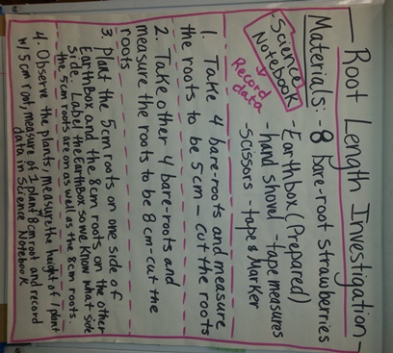
Mrs. Forinash’s Class – Anchor chart example

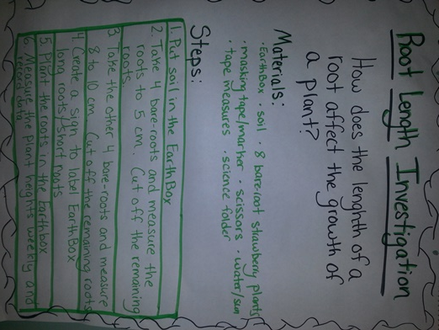
Mrs. Minor’s Class – Anchor Chart example

Pictures of students completing the measurement / planting tasks & bare-roots.
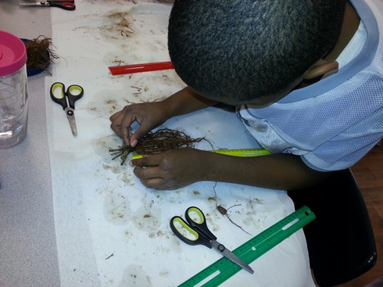

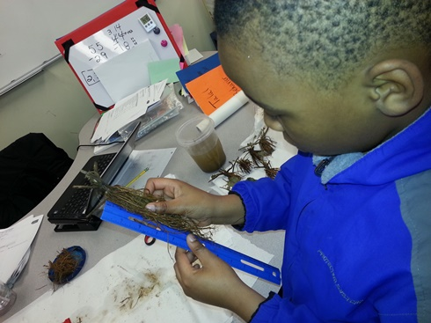

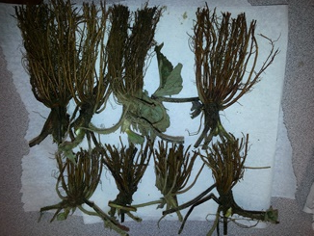
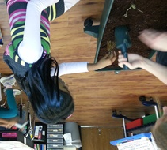
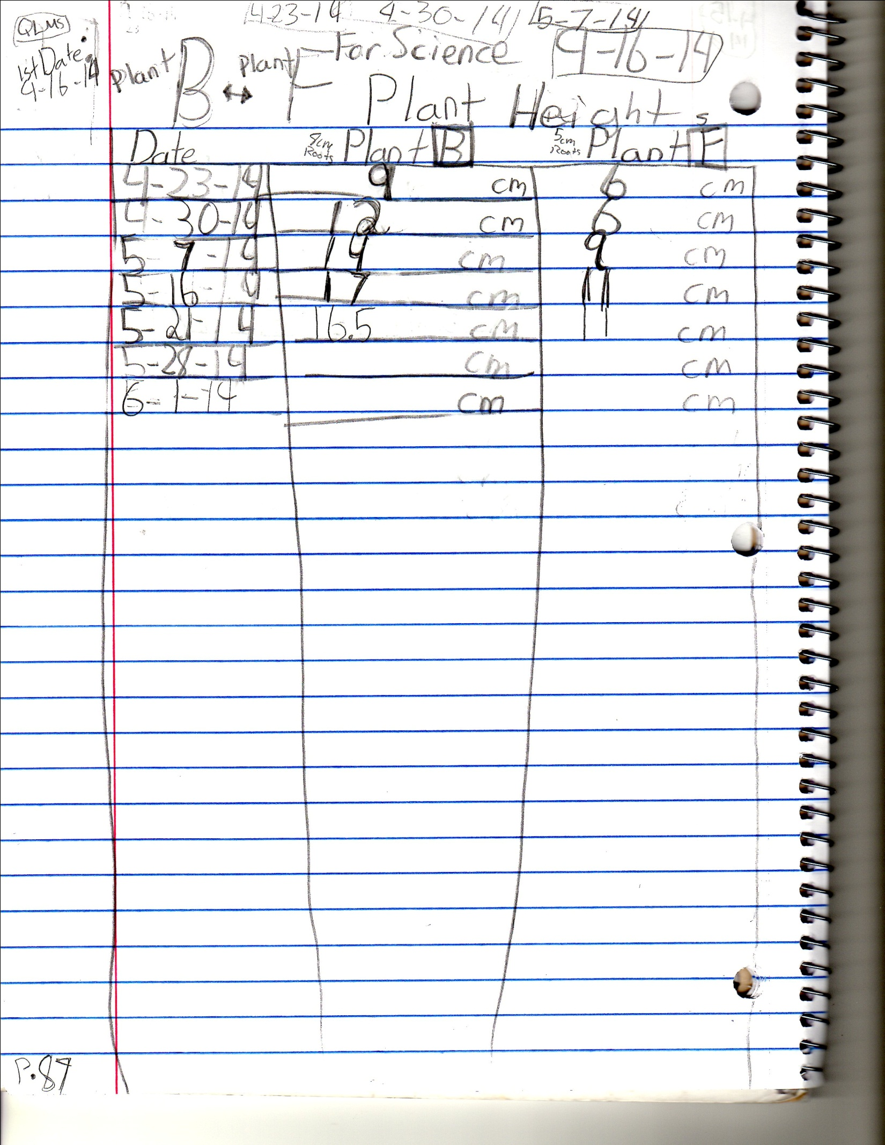
Sample of a student’s journal entries as she measured the plants that grew from the investigation

